Design

**Introduction**

This is the third phase of the development life cycle. Design is the early stage of development where a project’s important features, structure, criteria of success, and major deliverable are all settled and planned. This part is called as the blue print of the system where overview of the system us mentioned correctly.

This phase is called as the important because it helps to ensure that all the necessary requirement and features are fulfilled in the final stage of the project life cycle.

**Types of design**

There are several types of design and here are some of the chosen types of design pattern which are relevant to my project.

* Structural design
* Behavioral design
* Database design
* Architecture
* UI design

**Structural Design**

Structural design is a systematic methodology or pattern to determine specification of the project. The basic rules, tools and techniques of the structural pattern are applied in order to get full information about the project. The plan producer of any structure pattern begins with the choice of the materials against the development innovation. So, the creator to discover the safe, robust and efficient resolve of the building including solid, invention and the degree of basic individual adequate to convey heaps of the structure pattern during the survival period of the structure is said to be structural design pattern.

**Class Diagram**

Class diagram is the static diagram which represent static view of an application. Class diagram defines the attribute and operation of the class and also the constraints executed on the system. These diagrams are the only diagram which represents and maps with the oop and is widely used. Notation for the class diagram are:

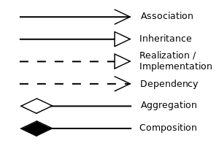

Some reasons to use the class diagram in my project are:

* As the system developed by me is web based all the static view of the system can be illustrated easily.
* As the system that is being developed uses the OOPs concept it is only pattern that can properly depict different aspects of OOPs concept.
* As there are many functionalities performed by system in the web-based application that is being developed it helps in the description of all the functionality that are performed by system.

**Data Flow diagram**

Data flow diagram are mapping of the flow of the information for any process or the system. DFD outlines are used to graphically represent the flow of information in a system. It shows the actions that are associated with a system exchange information from the influence to the document storing and description generation. Data flow diagram are used because of the following reasons:

* As there is flow of information and data so it helps to establish physical and automated systems desires.
* It helps as a backbone of physical system creation requirement.
* As it deals with the logical flow of data and information it helps to show the logical flow of the system.
* It helps to clarify the option the project will require so as to deal with the given information.

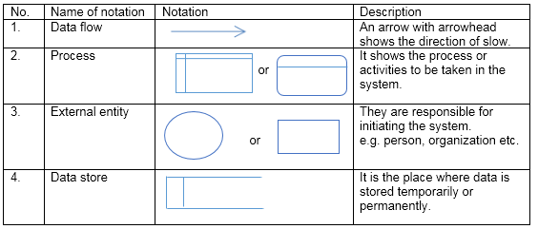

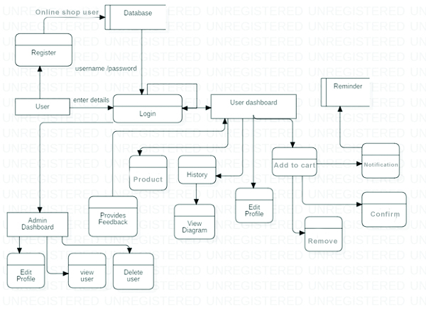

**Behavioral Design**

Behavioral design is the set of techniques for influence. Behavioral design is an innovation of conduct, not an innovation of power. To that degree, the procedure of behavioral design, and designer themselves, must regard individual’s inherent rights to opportunity of decision, self-governance and respect outline. Out of all this behavior design, the most appropriate diagram for my project are as follows:

**Sequence Diagram**

Sequence diagram is defined as interaction diagram which shows that how the operations are carried out in a system. They capture the interaction between objects in the context of association.

Sequence diagram is used in my project so as of following reasons:

* In my project it helps to model the high-level interaction between active object in a system.
* It allows us to discuss the design in concrete term so it can used as collaboration tool during design meeting.
* This diagram can be used to document the dynamic view of the system at various levels of abstraction, which is often difficult from static diagram.

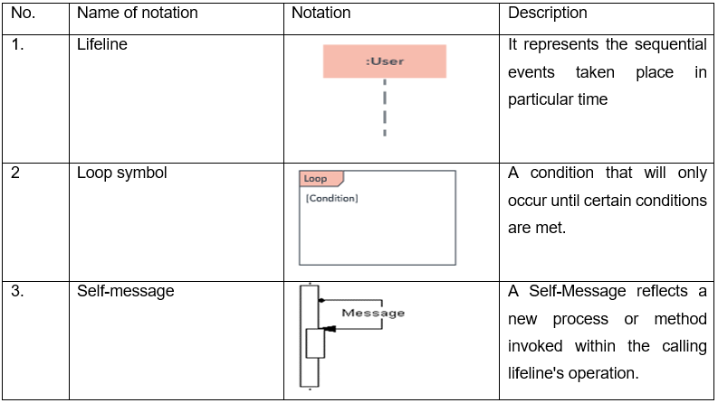

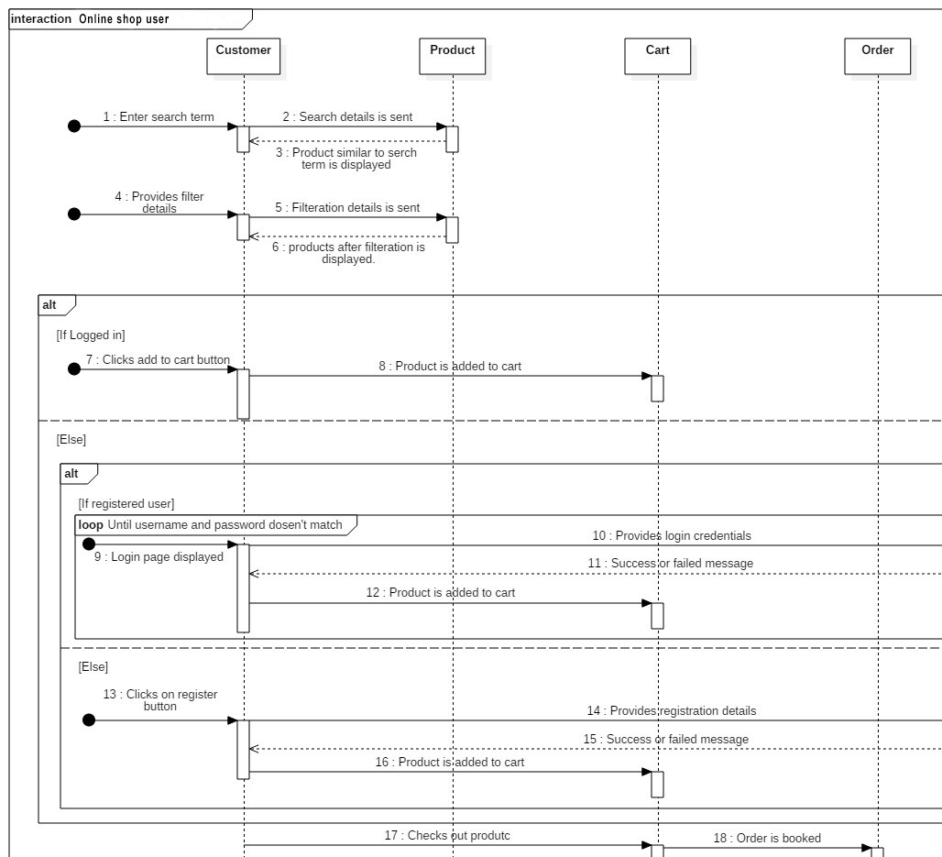

**Activity Diagram**

Activity diagram shows the flow of the system and state the steps tangled from the initial point to the finish point by the use of different decision paths that happens while performing the activity of a use case. Following are the reasons for using the activity diagram for my project:

* As there will be the presence of different non programmer so it is more user-friendly and easier to understand for all the stakeholder and the analysts.
* Programmer or coder can use this during the coding of the system as a blueprint of the control flow and can be used during the debugging of the system.

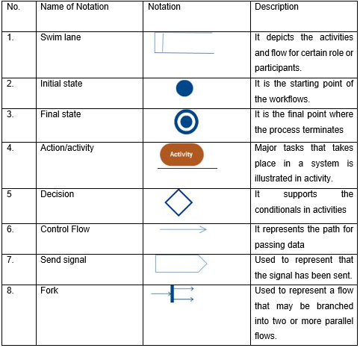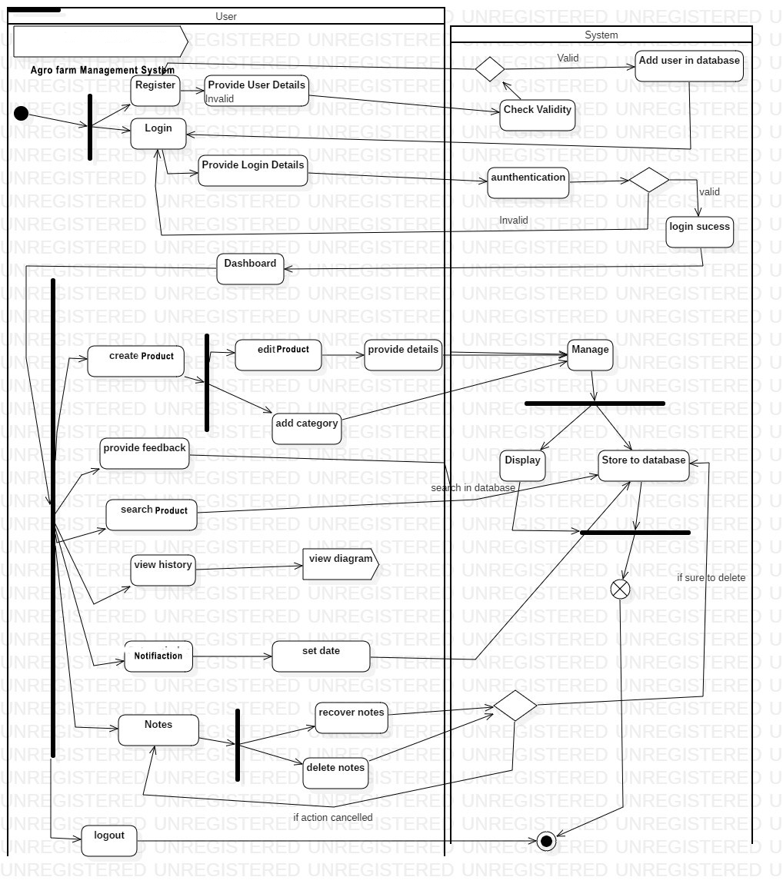

Database Modelling:

Data modelling here is used to represent a process by which data model are created for the data stored in database.

ER Diagram

An entity relationship diagram shows the relationship of sets of entity stored in database. An entity in this context is an object, a component of data. The entity relationship diagram helps in illustrating the logic of how entities work and its relationship with each other.

Attributes, action, connecting lines, entities and cardinality are mainly used component of ER diagram. These components are combined to make good ER diagram which identifies and defines the interaction between the entities.

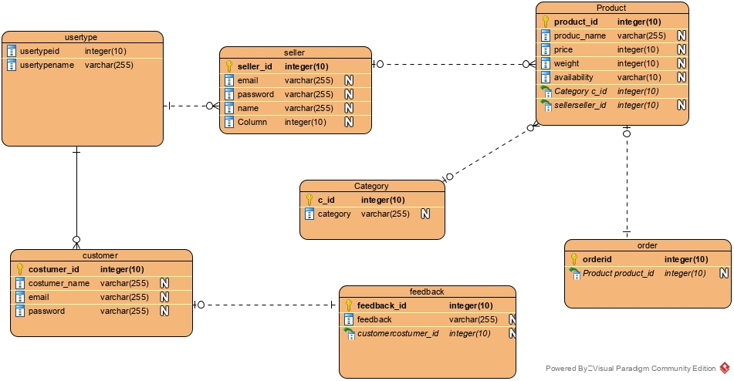

Here is shown the ER relation among all the tables and the entities that are seen on the project where there are total six table created for the project.

Data dictionary

Data dictionary is the process of gathering all sort of important information and its component such as name, attributes which are stored in a system, here for example name, traits and definition that are put away in database or a framework which can be useful in future. It also gives metadata about the put away information components. This makes the utilization and read of information less demanding and faster.

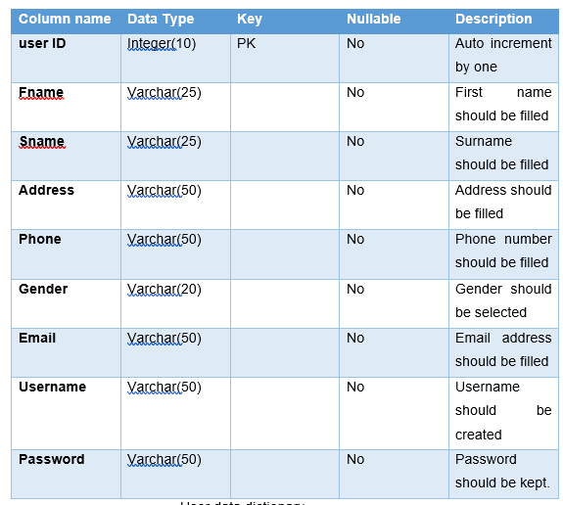

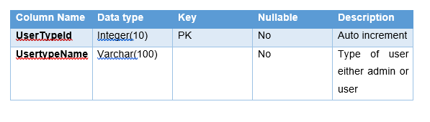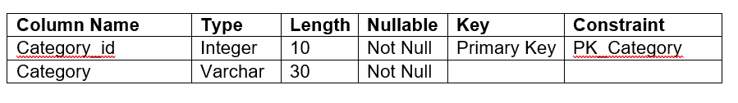

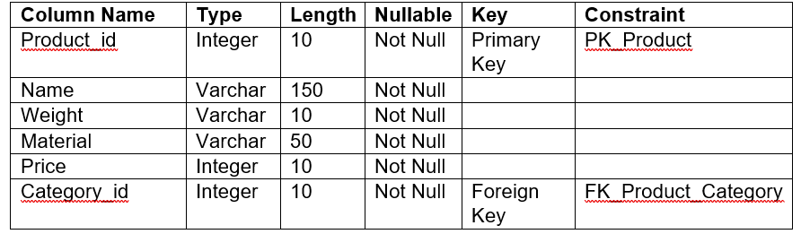

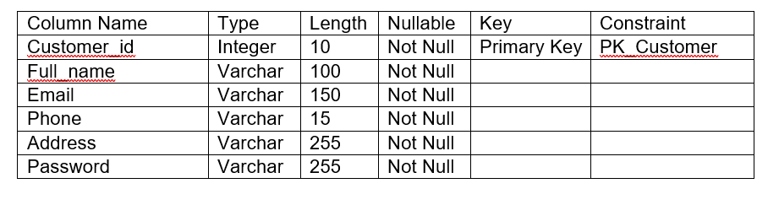

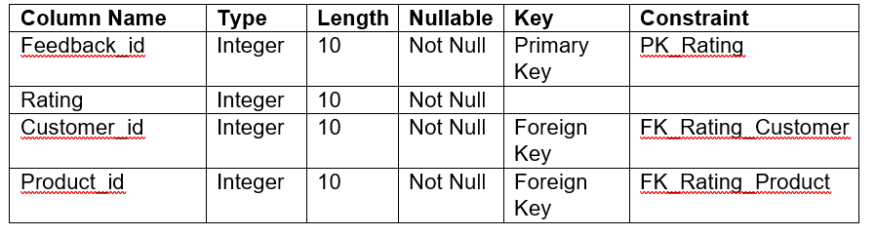

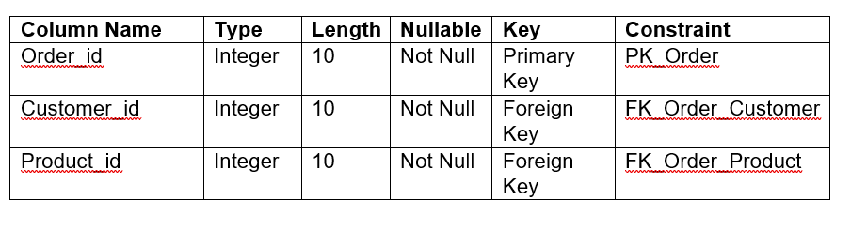

UI Modelling

UI modeling is an iterative analysis technique which in which the user activity is involved in the mocking up of the UI of the system. This modelling can be useful for the project as it shows the graphical interrace of the system that is being developed. This helps to illustrate what will happen in the system.

Prototyping

Welcome:

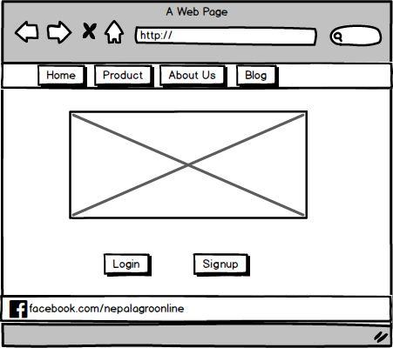

Login

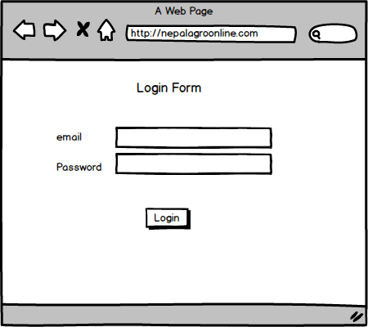

Sign Up

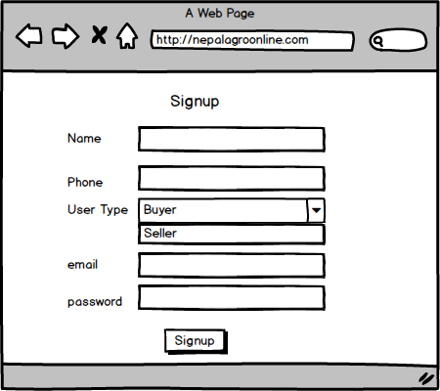

Dashboard

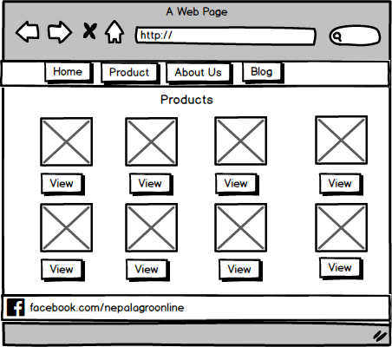

View Product

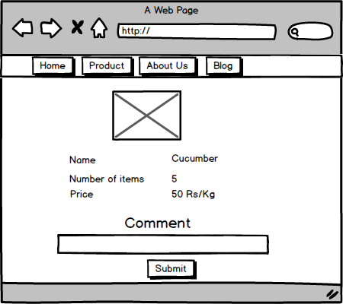

My cart



For the seller

Upload Product

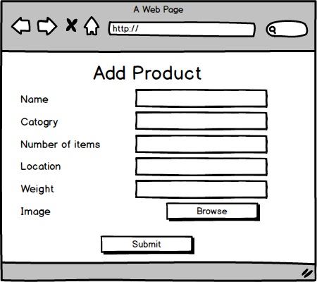

Blog



About Us page

